Iaas,Paas & Saas

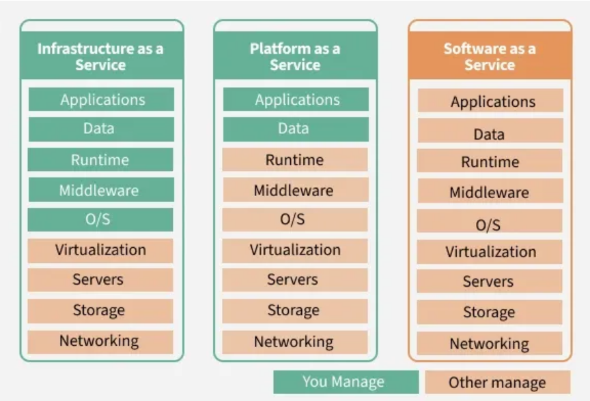

* Iaas
  + Infrastructure as a Service (Iaas) is a cloud service model that provides virtualized computing resources over the internet. It delivers essential infrastructure components such as servers, storage, networking, and computing resources on a pay as you-go use basis.
  + Unlike traditional on-premises data centers, IaaS enables businesses to rent physical resources without managing hardware directly. This flexibility allows businesses to scale up or down based on their needs, making it ideal for startups and large enterprises alike.

### Characteristics of IaaS (Infrastructure as a Service)

* + IaaS is like renting virtual computers and storage space in the cloud.
  + You have control over the operating systems, applications, and development frameworks.
  + Scaling resources up or down is easy based on your needs.

### Popular IaaS Providers:

* + Amazon Web Services
  + Microsoft Azure
  + Google Compute Engine
  + Digital Ocean
* Paas
  + Platform as a Service (PaaS) offers a cloud environment for developing, running, and managing applications without dealing with the complexities of maintaining the underlying infrastructure. It provides a platform that includes tools for app development, hosting, and runtime management. PaaS is aimed at developers who want to focus on building applications rather than managing hardware or operating systems.
  + A software development company building a SaaS product can use Google App Engine or AWS Elastic Beanstalk to deploy their web application without worrying about setting up servers, networking, or storage.

### Characteristics of PaaS (Platform as a Service)

* + PaaS is like a toolkit for developers to build and deploy applications without worrying about infrastructure.
  + Provides pre-built tools, libraries, and development environments.
  + Developers focus on building and managing applications, while the provider handles infrastructure management.

### Popular PaaS Providers:

* + AWS Lambda
  + Google App Engine
  + Google Cloud
  + IBM Cloud
* Saas
  + Software as a Service ([SaaS](https://www.geeksforgeeks.org/software-engineering/software-as-a-service-saas/)) is the most user-friendly model, providing complete software applications hosted in the cloud. Instead of purchasing and installing software on individual devices, users can access applications over the internet. SaaS eliminates the need for businesses to install, maintain, or manage software themselves.
  + In simple words "If you have no knowledge of coding, you can hire a third-party cloud service to build both the front-end and back-end of your application, along with handling their connectivity" this is SaaS.

### Characteristics of SaaS (Software as a Service)

* + Applications are ready to use, and updates and maintenance are handled by the provider.
  + You access the software through a web browser or app, usually paying a subscription fee.
  + It's convenient and requires minimal technical expertise, ideal for non-technical users.

### Popular SaaS Providers:

* + Salesforce
  + Google Workspace
  + Microsoft 365
  + Zoom
  + Slack

**Comparison Table**

| Feature | IaaS (Infrastructure as a Service) | PaaS (Platform as a Service) | SaaS (Software as a Service) |
| --- | --- | --- | --- |
| 🔧 Core Offering | Virtualized hardware resources | Development platforms and tools | Fully functional software applications |
| 🛠️ User Control | Full control over OS, storage, and network | Control over applications and data | Minimal control; mostly configuration |
| 🧱 Components Provided | Servers, storage, networking | Runtime, middleware, OS, development tools | Complete application, data, and infrastructure |
| 👩‍💻 Target Users | System administrators, IT professionals | Developers | End users |
| 📦 Examples | AWS EC2, Microsoft Azure VMs, Google Compute Engine | Google App Engine, Heroku, Azure App Services | Gmail, Salesforce, Microsoft 365 |
| 🧰 Customization Level | High | Moderate | Low |
| 💰 Cost Model | Pay-as-you-go for resources | Pay for platform usage | Subscription-based |
| 🔒 Security Responsibility | Shared (user manages OS and apps) | Shared (provider manages platform) | Mostly provider-managed |
| 🚀 Scalability | High, but user-managed | High, with platform-managed scaling | High, automatic |